PORTS Express Limited was established since December 1998 with a class 1 forwarding
company. We have several offices in China, USA and our Head Quarter is located in Hong Kong.
We have over 10 years of experienced qualified staffs. With a team of expertise, from global
corporations both with suppliers and freight forwarders, through high spirit of hard work and
complete devotion, has made us to be able to expand our wings to cover new territories and the
world.
We are a Class 1 Freight Forwarding Company, Holding licenses with:
International Air Transport Association ………………………………….
Non Vessel Operating Federation of Freight Forwarder …………………
The International Federation of Freight Forwarder Associations ………..
Transportation Intermediaries Association ……………………………….
Ηong Kong Logistics Association…………………………………………
Hong Kong Association of Freight Forwarding and Logistics Ltd………..
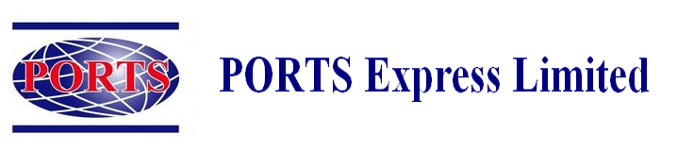
~ One Team One Goal ~
PORTS Express Limited is a company that specialized in following industries:
Aircraft parts and Aircraft engines
AOG- Aircraft On Ground
Computer equipment & computer parts, computer peripherals
Heavy Equipment & Machinery (Machinery Spare parts)
Generator set (generator parts)
Medical equipment (medical supplies)
Chemicals
Electrical materials
Construction materials
Radar equipments (radar parts)
Vessel Supplies
Industrial equipment
Office equipment
(Hardware & software)

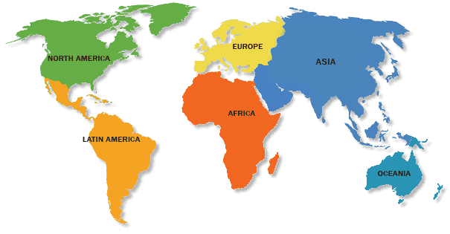

Scope Of Services
- To provide freight management inclusive of international air-freight/ocean and local delivery
- To provide 24 hours a day, 7 days a week and 365 days a year service
- Short/Long Term storage
- Inventory Management
- Door to Door services
- Cross check documents
- Monitor uplift of cargo
- Obtain proof of delivery
- Prepare monthly performance report

Our Mission is to provide Clients with professional high quality and competitive services related to cargo transportation by air, ocean and road. We are confident with our knowledgeable staffs, we can ensure you with the quickest possible response to all your transportation inquirer in which you will not find other company with a stronger commitment to customer service in the industry we have experienced and well trained qualified staffs to take care of
our customers cargo like their own freight. We have great connections with Airlines & Ocean Carriers to be able to provide competitive rate to our worldwide cliental. Whatever our customers request, we will bring solutions to them. Our customers’ satisfaction is our goal and we will always do our best to achieve that. To reach the mission target, all team members within PORTS Express Limited, are standing by at our Corporate philosophy and
slogan.
~ One Team One Goal ~

Our Offices
We have our offices throughout the main city of United States and China, such as: Los Angeles, San Francisco, Chicago, New York, Shanghai, Guangzhou.
Our worldwide network is covering all major continents from Hong Kong to China and Worldwide. Our company is one stop service for all around the world. We provide high quality service to and from every major port around the world.



Value Added Services:

AO Container Lines, Inc offer a value added services to all of our customers, no matter you ship small box or a full truck of pallets. This is in order to better serve and protect cargo from unexpected weather. We will add palletizing & shrink wrapping, polyethylene top, heavy duty V boards, poly strapping with metal clip, special handling label, security tape and extra label, bubble plastic wrap for sensitive cargo, etc. All these are our value added services that we offer to make sure your cargo get from origin to destination in a safest manner.

Other Extra Products and Services we provide:

AO Container Lines, Inc offers cargo insurance so that you can best double protect your investment in order to avoid any possible risk or damage to your cargo from unexpected incident while in transport. The cost of insurance is separated from shipping cost of the cargo.

Oversize Cargo Services:

AO Container Lines, Inc is also specialize in handling oversize cargo, project cargo that are *out of guage* and need special attention and delivering process.
SERVICES INTRODUCTIONS

Air Freight:
Your Single Source for Air Freight Services Worldwide to meet your freight deadlines, you need and Air Freight service provider with high performance standards and the flexibility to meet your changing needs.Ports Express can meet your Air Freight requirements with confidence and reliability. Global Access to ExpandYour Horizons. With our door-to-door service to major metropolitan areas around the globe. We offer a full array Of value-added service options for convenient and simple shipment processing of palletized or loose shipments.

Ocean Freight:
Keep Your Business Sailing Worldwide, Ports Express offers a full array of global Ocean Freight and Transportation services. We can handle almost any size shipment, from less-than-container loads to full container Loads, special equipment, and oversized cargo. From almost any origin, destination or carrier, we can provide streamlined freight forwarding to book your cargo, arrange for pickup and delivery, and manage the shipping Documentation. We facilitate the entire forwarding process according to your pecifications as well as the Requirements of the import and export countries. Ports Express is a Non-Vessel Operating Common Carriers (NVOCC), We can maximize your routing and transit time options by managing your ocean shipments Door-to-door, with ease, visibility and global reach.

Customs Clearance:
Ports Express In-House Customs Brokers has been helping our customers ensure their imports are cleared
accurately and timely for over the past years. Our automated interfaces and brokerage know-how fueled by a team of licensed Customs Brokers enables us to classify your goods correctly and accurately. Today’s emphasis on secure supply chains, compliance issues, trade agreements, reporting requirements and global communications requires that you select a Professional Customs Broker to handle your customs needs. Ports Express In-House customs Brokers is that firm. Our Brokerage constant internal upgrading of our Brokerage skills, we keep up-to-date on the ever changing import and export regulations.

Ground Freight Services:
Ports Express provides the most exceptional ground freight forwarding services nationwide. With the most Efficient Services and agents throughout the United States, Ports Express provides seamless supply chain management. Utilizing commercial and freighter fleets throughout the nation, along with the most extensive ground transportation network in the business, Ports Express stands ready at all times to react successfully to even the most urgent of
shipments. For same day, next morning, or next day deliveries, Ports Express has the best on time percentage in the airfreight industry. Ports Express also offers the most comprehensive ground transportation available. From Less than Truck Load (LTL) to expedited Truck Load services. Ports Express stands ready to partner with you on all of your air and ground transportation needs.
Value Added Services:

AO Container Lines, Inc offer a value added services to all of our customers, no matter you ship small box or a full truck of pallets. This is in order to better serve and protect cargo from unexpected weather. We will add palletizing & shrink wrapping, polyethylene top, heavy duty V boards, poly strapping with metal clip, special handling label, security tape and extra label, bubble plastic wrap for sensitive cargo, etc. All these are our value added services that we offer to make sure your cargo get from origin to destination in a safest manner.

Other Extra Products and Services we provide:

AO Container Lines, Inc offers cargo insurance so that you can best double protect your investment in order to avoid any possible risk or damage to your cargo from unexpected incident while in transport. The cost of insurance is separated from shipping cost of the cargo.

Oversize Cargo Services:

AO Container Lines, Inc is also specialize in handling oversize cargo, project cargo that are *out of guage* and need special attention and delivering process.
SERVICES INTRODUCTIONS

Air Freight:
Your Single Source for Air Freight Services Worldwide to meet your freight deadlines, you need and Air Freight service provider with high performance standards and the flexibility to meet your changing needs. PORTS Express Limited can meet your Air Freight requirements with confidence and reliability. Global Access to Expand your Horizons. With our door-to-door service to major metropolitan areas around the globe. We offer a full array Of value-added service options for convenient and simple shipment processing of palletized or loose shipments.

Ocean Freight:
Keep Your Business Sailing Worldwide, PORTS Express Limited offers a full array of global Ocean Freight and Transportation services. We can handle almost any size shipment, from less-than-container loads to full container Loads, special equipment, and oversized cargo. From almost any origin, destination or carrier, we can provide streamlined freight forwarding to book your cargo, arrange for pickup and delivery, and manage the shipping Documentation. We facilitate the entire forwarding process according to your specifications as well as the Requirements of the import and export countries. PORTS Express Limited is a Non-Vessel Operating Common Carriers (NVOCC), We can maximize your routing and transit time options by managing your ocean shipments Door-to-door, with ease, visibility and global reach.

Customs Clearance:
PORTS Express Limited In-House Customs Brokers has been helping our customers ensure their imports are cleared
accurately and timely for over the past years. Our automated interfaces and brokerage know-how fueled by a team of licensed Customs Brokers enables us to classify your goods correctly and accurately. Today’s emphasis on secure supply chains, compliance issues, trade agreements, reporting requirements and global communications requires that you select a Professional Customs Broker to handle your customs needs. Ports Express In-House customs Brokers is that firm. Our Brokerage constant internal upgrading of our Brokerage skills, we keep up-to-date on the ever changing import and export regulations.

Ground Freight Services:
PORTS Express Limited provides the most exceptional ground freight forwarding services nationwide. With the most Efficient Services and agents, We provides seamless supply chain management. Utilizing commercial and freighter fleets throughout the nation, along with the most extensive ground transportation network in the business, We stands ready at all times to react successfully to even the most urgent of shipments. For same day, next morning, or next day deliveries, We has the best on time percentage in the airfreight industry, and also offers the most comprehensive ground transportation available. From Less than Truck Load (LTL) to expedited Truck Load services. PORTS Express Limited stands ready to partner with you on all of your air and ground transportation needs.

SERVICES INTRODUCTIONS
~ One Team One Goal ~
Oversize Cargo Services:
PORTS Express Limited specializes in the transportation of Oversize/Heavy
Haul and Project Cargo to and from worldwide destinations. We are
experienced in handling large heavy lift items, long length cargoes and bulky
items utilizing the most reliable and fully insured carriers thereby providing
an efficient, seamless, and cost effective solution to meet your current and
future challenges. Ports We pay special attention to detail, aware that
each shipper has unique requirements. We draw upon specialized services to
help our clients achieve their goals.

Value Added Services:
Ports Express offers a value added service to all of our
customers. This is in order to protect your cargo and to better
serve our customers. We will add palletizing to the cargo that
needed them to better protect the cargo. We shrink wrapping the cargo, we added Polyethylene Top, some we added Heavy Duty V Boards to protect the corners. We use Poly Strapping with Metal Clip, we past Special Handling Label; we added Security tape and extra label. We even provide bubble plastic wrap for sensitive cargo. All of these value added has proven that our company always has customer’s oriented mind. We care about your cargo such as our own.
Warehouse Services:
PORTS Express Limited knows the necessity of the warehousing, our
motto is going the "extra mile" for our customers. We provide all the
necessary tools that we are capable off, such as, the space to store your
cargo, the forklift, pallets, electronic scales, pallet jacks, etc. Our operation is big enough to provide excellent service to the needs of large customers, but our approach to service provides a platform to service the needs that smaller customers require as well. We can warehouse almost anything from chemicals to any commodities in our warehouse, Whether you need smaller amounts of space for your merchandise or a whole trainload, we can take care of your needs.

Other Products:
PORTS Express Limited USA also offers below product and services to our
Customer as per requested:
- Licensing & Documentation
- Letter of Credit, Banking Service
- Global Logistic Supply Chain Management Consultancy
- Carnet-Exhibition cargo & Trade show

SERVICES INTRODUCTIONS

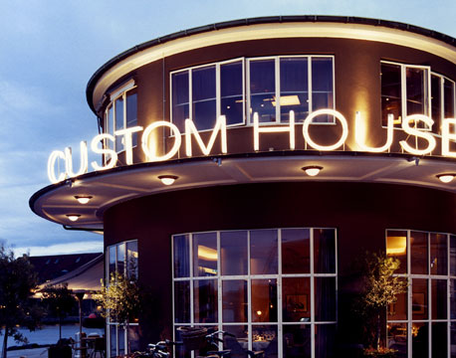

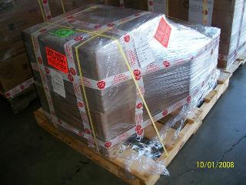

~ One Team One Goal ~

Qualifications and Membership

- China Class A License (No. 3100001753)

- China NVOCC License (No. MOC-NV03078)

- USA FMC License (No.021641N)

- IATA member

- FIATA member

- Hong Kong Association of Freight Forwarding and Logistics (HAFFA) member

Hong Kong Logistics Association member

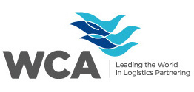

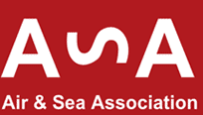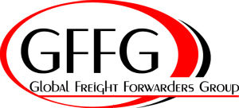

~ One Team One Goal ~

PORTS Express Limited History

1998 – PORTS Express Limited established at Hong Kong

1999 – Macau office setup.

2005 – Shanghai started its operation under China Class “A” Licencse,
- Since then, PORTS Express Limited are making steady progress and increasing market share in today’s phenomenal freight sector.

2007 – Network developed to Guangzhou
- Licensed China NVOCC

2008 – PORTS Express (USA) Inc. – with USA FMC License.

~ One Team One Goal ~

MAIN CONTACT INFORMATION

Hong Kong Headquarter

Unit B, 11 floor, Gee Luen Chang Industrial Building,
No. 11 Yuk Yat Street, Tokwawan,
Kowloon, Hong Kong.
Tel : (852) 2402 9009
Fax: (852) 2766 2633
Contact : Johnny Tao – General Manager
E-mail : jtao@ports-express.com.hk

China

Shanghai Office
Room 1501, Aerospace Building,
No. 525 Si-Chuan North Road,
Shanghai, China
Postal Code : 200085
Tel : (86-21) 6306 2990
Fax : (86-21) 6306 0319
Contact : Horace Ho – Station Manager
E-mail : horaceho@ports-express.cn

Guangzhou Office
Unit D, 15 floor, Zhzngqiao Building,
No. 76, Xian Lie Zhong Road,
Guangzhou, China.
Postal Code : 510095
Tel : (86-20) 8732 6886
Fax : (86-20) 3758 4184
Contact : Ivy Huang – Station Manager
E-mail : ivy@ports-express.cn.

Macau
Estrade Cemiterio, NO. 25, 2 Andar,
A2 Edif, Wan Keng, Macau.
Tel : (853) 2836 2231
Fax : (853) 2836 2932
Contact : Rocs Lei
E-mail : rocslogistics@yahoo.com.hk
U.S.A.

Los Angeles Office
No. 421, N. Oak Street, Ingelwood, CA90302.
Tel : 310-671 3388\
Fax : 310-419 8832
Contact : Ignacio Ortiz – Station Manager
E-mail : ignacioo@portsexpressusa.com

San Francisco Office
No. 380, Swift Ave, Unit # 23, S. San Francisco, CA94080
Tel : 650-588 7368
Fax : 650-588 7313
Contact : Erica Wong – Station Manager
E-mail : ericaw@portsexpressusa.com

Chicago Office
No.729, N. Route 83, Suite # 311, Benseville, IL60106
Tel : 630-766 2100
Fax : 630-766 2106
Contact : Ken Lu – Station Manager
E-mail : kenl@portsexpressusa.com

New York Office
No. 147-31, 176 TH Street, Jamica, NY11434
Tel : 718-995 3880
Fax : 718-995 2878
Contact : Peter Hon – Station Manager
E-mail : peterh@portsexpressusa.com

24 HOUR AOG CONTACT

HONG KONG & Macau

Taddy Chan
(852) 9209 2346

Penny Leong
(852) 9163 8320

CHINA

Samson Lam
(86) 159 0171 2046

Ivy Huang
(86) 135 8033 9209

U.S.A.

Ignacio Ortiz
(1-323) 998 3144

Alan Chan
(1-626) 757 0168

Nick Delgado
(1-323) 470 2307
~ One Team One Goal ~

