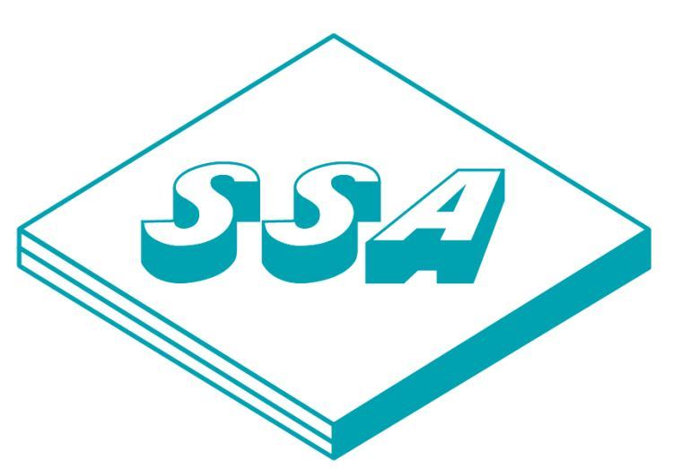

We at Sharaf Shipping cater to freight forwarding services, whether Port to Port or Door to Door, for Sea, Air and Road including FCL & LCL for global trade lanes. We use the extent of our strong network for optimization of your supply chain basis demands of partners.

We have coverage within full range of services from Freight to Custom Clearance, from Transport to Storage and from pick up to delivery through our professional team and robust IT systems.

Our active and well-connected team brings specialized contracts with Carriers for a cost effective and reliable transport over Sea and Air for Dry / Bulk / Break-Bulk / Liquid including ISO Tank.

Sharaf Shipping at Saudi Arabia has a reliable infrastructure to meet your diverse requirements.